3.1 - Editors - 3D View
3D View editor 2
Hotkey only functionality 3
Trackball rotation 3
Calling Menus under the mouse 3
Add to selection with Shift 3
Constraining the scaling axis (axis locking) 3
Transformation with the widget along two axis 4
Snapping with Increment snap 4
Description 4
Fine tuning Transform 4
Rotation transformations 5
Scale transformations 5
Numeric input for Transform 5
3D Cursor 6
Placement 6

3D View editor

The 3D View editor is the editor where you edit your 3D data. Here you can display and modify meshes, curves, metalballs, etc.
It has by default a grid in the middle. And you can navigate around in this view. To see the basic navigation hotkeys, activate the Important hotkeys tool in the tool shelf.

The 3D View is made of four areas. Actually five. The tool shelf is divided into two parts.
In the middle is the actual viewport. Here you see and modify for example your mesh data.
At the left you can find the Tool Shelf. It contains all the tools. The tool shelf is divided into two parts. The upper parts is the actual tool shelf. The lower part is the Last Operator panel. Here you can adjust tool settings for the currently active tool.
At the right you can find the Properties sidebar. It contains settings and transform values.
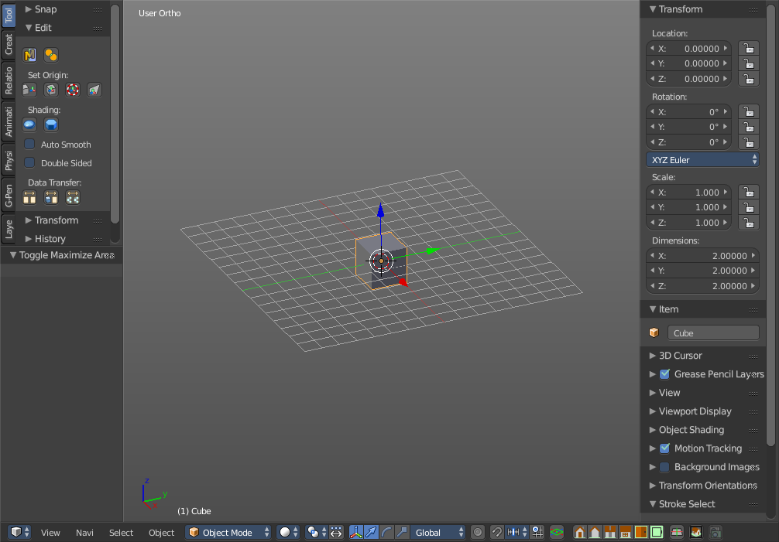
Below you can find the header. It contains menus and some important tools.

Hotkey only functionality

Not every functionality has a menu entry. Some of them are mentioned in the Important Hotkeys tool in the Properties sidebar. Some not. We will try to document them here.

Trackball rotation

Pressing the hotkey for rotation once will rotate the object around the screen axis. Pressing the hotkey for rotation twice will activate trackball rotation. Now you can rotate the object freely around all three axis.

Calling Menus under the mouse

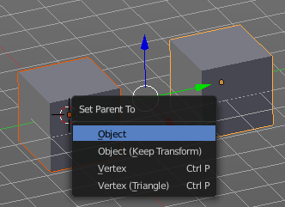
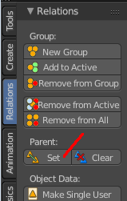
Some menus can be called by hotkeys at mouse position. This is for example the case for parenting. Ctrl + P will call the Set Parent To menu. It's the same menu that appears when you click at the parent set button in the tool shelf in the Relations tab. Another example is the unwrap menu with hotkey U in edit mode.

In Bforartists the number of menus that can be called this way is as reduced as possible. The normal useage way goes across the tool shelf and the header menus.

Add to selection with Shift

When you want to parent two objects together, then you need to select them. You can do this with border select for example. Or you select the first object, hold down shift, then the second object. The first object selected will be the child object then when you parent them together.

Constraining the scaling axis (axis locking)

Scaling can be constrained to a particular axis or axes through the use of Axis Locking. To constrain scaling, the following shortcuts can be used:
- Scale Hotkey, X: Scale only along the X Axis
- Scale Hotkey, Y: Scale only along the Y Axis
- Scale Hotkey, Z: Scale only along the Z Axis
Axis locking can also be enabled by pressing the MMB after enabling scaling and moving the mouse in the desired direction e.g.
- Scale Hotkey, move the mouse along the X axis, MMB: Scale only along the X Axis

Transformation with the widget along two axis

Normally you grab a handler of the widget, and pull in the direction of this handler. With the blue handler you will pull in Z direction. A blue line will indicate the pull direction.
When you hold down shift and click at the blue handler., then you can move the object along a plane in X and Y direction. The blue and red line appears to show the pull direction.
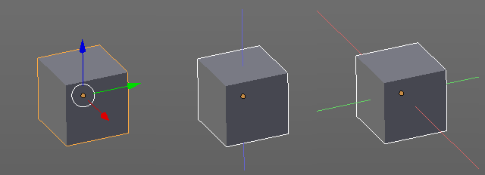

Snapping with Increment snap

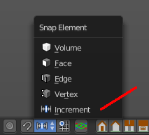
Description
Holding Ctrl during a transform operation (such as grab, rotate or scale) will activate Transform Snapping. When the Snap Element is set to Increment, this allows the transformation to be performed in fixed steps.

Fine tuning Transform

Holding Shift during a transform operation will transform the object at 1/10th the speed, allowing much finer control over the snapping.
The magnitude of the transformation can be viewed in the 3D window header in the bottom left hand corner. Releasing Ctrl or Shift during the transformation will cause the movement to revert back to its normal mode of operation.
This fine tune transform operation works with both, the transform hotkeys and the 3D widget.
Tip
Combining with other controls
All of the precision controls detailed on the page can be combined with the Axis Locking controls and used with the different Pivot Points.

Rotation transformations
Holding Ctrl will cause rotations of 5 degrees.
Holding Ctrl-Shift will cause rotations of 1 degree.

Scale transformations
Holding Ctrl will cause size changes in increments of 0.1 BU.
Hold Shift down while scaling to scale the selected element in very fine increments.
Hold Shift-Ctrl down while scaling to scale the selected element in 0.01 BU increments.
Tip
Orientation dependent scaling
By default, all scaling happens around a Global Orientation. You can change the scaling orientation by pressing the axis key twice. For example, pressing S, X, X will by default set scaling to occur around the local orientation in X direction.

Note
Snapping modes
Note that if you have a Snap Element option enabled, holding Ctrl will cause the selection to snap to the nearest element.

Numeric input for Transform

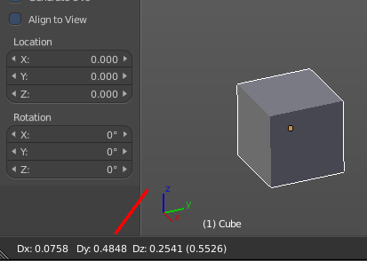
Using the mouse for transformations is convenient, but if you require more precise control, you can also enter numeric values. After pressing one of the navigation hotkeys, type a number to indicate the magnitude of the transformation.
You can see the numbers you enter in the bottom left hand corner of the 3D window header. Negative numbers and decimals can be entered by pressing the minus (Minus) and period (.) keys respectively.
The process is the same for translation, rotation and scale. Press the corresponding navigation hotkey, the header will show the values, then type in the values that you need. And finally left click or press enter to confirm. A right click abandons the operation.
For translation you have to define the axis in which you want to translate. So when you want to translate your object in X axis to 10, then press the translation hotkey, then type in X 10. And the object will arrive at X position 10. Keep in mind that pressing the navigation hotkey twice will work in local orientation.

3D Cursor
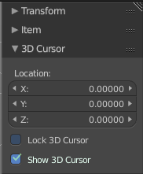
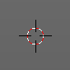
The 3D Cursor is simply a point in 3D space which can be used for a number of purposes. It is often in the way. You can hide it in the properties sidebar in the 3D Cursor panel at the right.

Placement
There are various methods to place this 3D cursor, including some snapping methods.
The free placement method with a hotkey is with Alt + RMB with the default Bforartists keymap.

